World Transplant Games 2019 – Newcastle/Gateshead – My Week
In September 2018 I was informed that I had been selected to join WTG along with 7 others. I was selected to swim and spent October 2018 – August 2019 training hard! I joined the Sunderland Masters Swimming club for coaching, I joined the Transplant Sport Swimming club for race practice and trained with a mix of swimming and land training 5-6 days per week. I am a person that loves goals and the more challenging the better and this was certainly going to be achallenge as I knew the standards I had to reach. Throughout the year we met as an enormous GB team three times at Warwick University which was great as we were able to bond, especially as a swimming team.
Fast forward – August 17th 2019!
Saturday
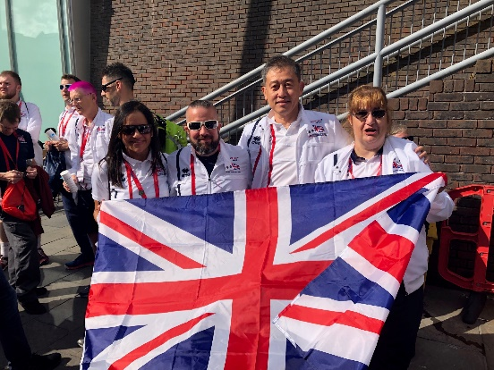
A gorgeous sunny evening welcomed the teams to Old Eldon Square ahead of the opening ceremony. A wonderful parade followed and the streets of Newcastle gave a great welcome to the competitors across the globe, A great ceremony inside Sports Central then saw the WTG officially opened.

Sunday
The following day was the Gift of Life Run in Exhibition Park. The sun was shining bright and it was a run that everyone could sign up for. I was unable to run or take part but was lovely that my family (including dog!) could. Also it was great to see many of the Freeman gang celebrating the gift of life.
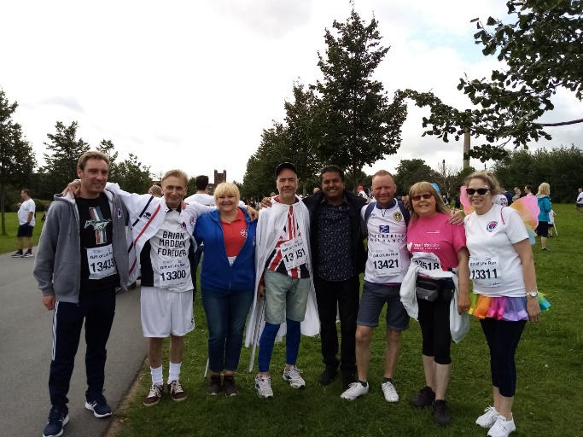
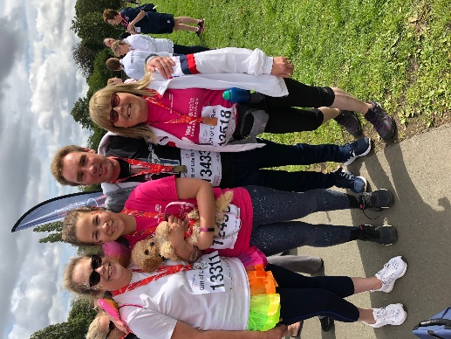

Monday
Saw training with the swimming team at the Sunderland Aquatic Centre. A great session was delivered followed by a lunchtime news live television broadcast as this day 40 years ago was also the first heart transplant! Later that afternoon a physio appointment with the amazing team of physiotherapists at the Hilton Newcastle followed by a swimming team meeting it was time to sleep.
Tuesday and Wednesday
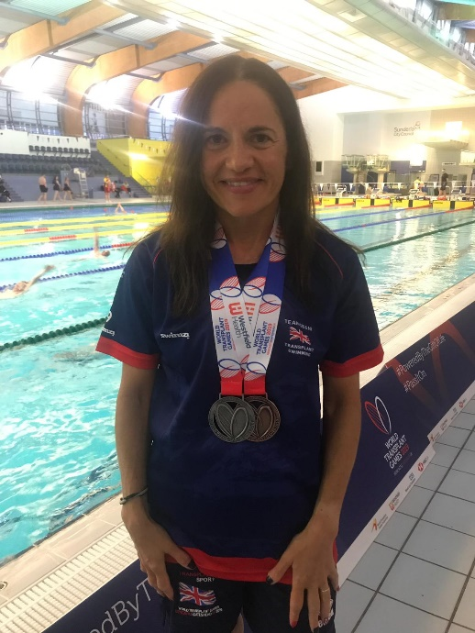
Started with early nervous starts as these were the days I had worked so hard for. The atmosphere at the pool was brilliant and the swimming amazing with a lot of tough competition. I had great support from my family, close friends and swimming club. The days were exhausting, emotional and above all awesome. I am thrilled with achieving PB’s in my events and gaining a silver and bronze medal which was beyond my wildest dreams. The exhaustion I felt at the end of Wednesday was unreal and sleep not a problem that night!

Thursday
Another early start at Newcastle Central Station where I was invited to join representatives from team GB to meet one of the WTG sponsors. A great morning listening to a lovely choir and singing and dancing with mascot Hope! Not the usual goings on for commuters in Newcastle!
Thursday afternoon were a great chance to relax and cheer on my teammates taking part in the track and field events at the stadium. Again, the sun was shining, and it was two great days of athletics.
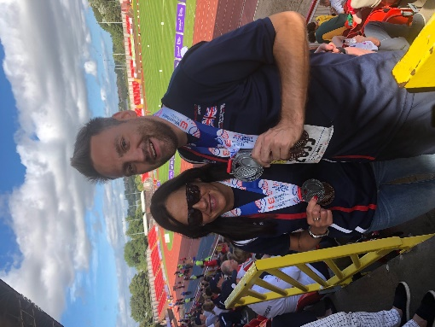

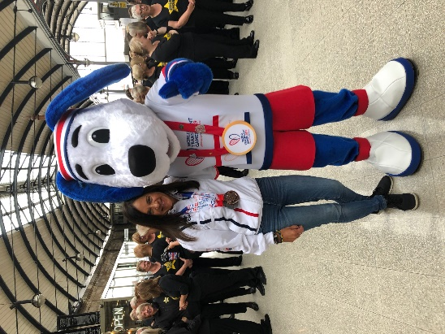

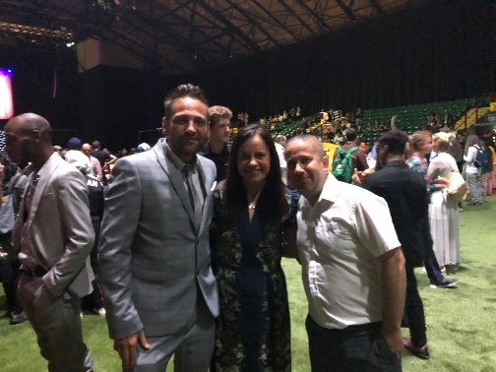
Friday night
And the games were closed at a lovely event at Utilita Arena. Again I was lucky to be able to have my family with me and a great opportunity to relax with friends and say bye to the people I had grown so close to over this journey.
Now, two weeks later I still have to pinch myself at what I have achieved. For 43 years I was unable to do any aerobic exercise. Thanks to the gift of life, my amazing donor and his incredibly strong family gave me a new start. It hasn’t been without its challenges. I had absolutely no muscle strength and for the past two years I have suffered with severe arthritis but I was and still am determined to always take on challenges that would never have been possible before transplant and hopefully in doing so encourage more people to think about organ donation.
The past twelve months of training have been gruelling at times, time consuming and sometimes costly but I have loved it all and especially in the swimming team have made friends for life.
If you are reading this and think you would like to work to take part in World Transplant Games 2021 in Texas the qualifiers will be at the BTG in Coventry 2020 but get in touch with me and let me know.
If you have never competed in any Transplant Games, think about joining us in Coventry, there is something for everyone!

Louise Mclellan
Freeman Team Sports Manager
mclellanuk@yahoo.co.uk

