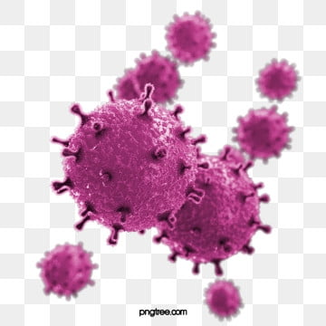
I have been asked by various people to share my experience with Covid-19 with other transplant recipients as I know it is something many are fearful of.
From the start I want to let you know I was not tested at the time as tests were not readily available then but the medics in terms of my GP and Transplant team believed I had it.
On Easter Sunday we had a lovely lockdown family day, I had cooked a large Easter dinner, played some games with my daughter and ended the evening with a regular zoom chat with other transplant friends. All day I had felt exhausted but just put it down to doing a lot. About 9pm I started to feel very cold even though it was a warm night. I took my temperature which was well over 38 deg so dosed myself up with paracetamol and went to bed. Throughout the night My temperature raised more, and I felt extremely feverish and unwell. On the bank holiday Monday, I contacted 111 online and put in my details. Within 10 minutes I was called back, and they instructed me I needed to see my GP immediately. They communicated with my GP and about 30 minutes later I had a home visit. My temperature was rising every 4 hours to 39.8 deg but coming down in between with paracetamol. After a thorough examination my GP was certain I had Covid-19. He told me not to think the worse as my body currently seemed to be coping. I owned an o2 sat monitor and was instructed to drink 8 or 9 glasses of water a day, monitor O2 sats, breathing rate, walk around and do some breathing exercises. For the next 5 days I remained in bed with no appetite, feeling very unwell however, at any time when my temperature was under control, I drank gallons, dragged myself off my pillow to walk around my bedroom and try and do breathing exercises which I had been given 6 years ago post-transplant. Throughout these five days I was petrified of needing to go into hospital. I would have certainly gone if my measurements had deteriorated as instructed but this would have meant my daughter seeing me taken away in an ambulance and she has been through that so many times pre-transplant, knowing she wouldn’t have been able to follow me would have been heartbreaking. It was a very strange time as I felt so unwell yet all the time knowing the next day could be the turn for the worse. I did develop the cough and my breathing certainly became a lot shorter, but I continued with moving, drinking and breathing exercises and on day 6 I did feel I was over the worst. For about another 3 weeks I felt exhausted and after 4 weeks I did have another temperature spike for 2 days. During this time tests were available, and I tested negative which was not really a surprise to anyone. I’m not sure I ever will know for certain if I had this virus but whatever it was made me very unwell and I am extremely scared of getting it again and therefore will take the shielding guidelines all the way, however, just because we are transplant recipients and extremely vulnerable, if anyone does find themselves in this position remember don’t assume the worst and work hard to kick it’s butt!

