London Marathon Journey : a running commentary - August
It’s becoming all too obvious that I need to get back to work. I’m causing far too much chaos at home – white t shirts are turning pink, worktops need to be sanded and wine glasses are being dropped.
The reality is, though, that returning to my job as an occupational therapist at the regional spinal cord injury unit is complex. Ironically I am well enough to do my job, arguably fitter than I have ever been, but the environment isn’t safe. I know I’m not alone with this and that many of us may need to re think career choices.
So, actually, preparing for my very first marathon seems to have come at a good time. Whilst so much about the future is unknown, the need to stay focused, keep fit and start dipping my toe into the world of the marathon is real, and for that I am truly grateful.
Before corona virus had reared its ugly head, I had planned to run the Rock and Roll half marathon in Liverpool, scheduled for May. This was postponed until October. I had literally just booked our hotel (keyboard still warm) when it was announced that the event had been cancelled for this year. As I write, the organisers of the London Marathon are also debating over its timing.
The need to stay positive and gently move forward, despite the setbacks, is what I need to do for now. My plan is still to run a half marathon distance in my local area in October and I hope to improve my time. My very first half marathon (a Great North Run , 2 years post-transplant) took me 3 hours and 21 minutes. My husband was incredibly patient and “ran” with me. My most recent half marathon took me 2 hours and 48 minutes which, to be honest, is still quite slow.
I’ve been part of formal running groups in the past but always felt an outsider, a burden, quite literally an “also ran”! Recently, however, joining a group of runners of varying abilities has been a game changer. Some of us met (first time since Lockdown) last week for a steady 3 mile run which I loved.
I’ve started to listen to a few pod casts (the Lockdown staple) about running and it has made me recognise the need for me to address my balance (dreadful) and my strength (improving) and find my own pace. I’ll let you know how I get on…

My first Great North Run – 2006:

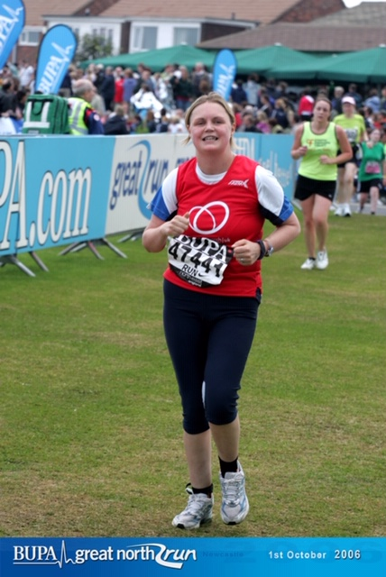

My most recent Great North Run (2017) with Sonic the Hedgehog
(aka my lovely husband Mark):

