London Marathon Journey – February
February is an eventful month for me. Firstly, I always get older (my birthday) and secondly it brings the date of my transplant. A day which, in lighter moments, I call my “traniversary”.
The day itself feels different each year and brings with it, a volatile mix of emotions which can catch me by surprise. I feel that it’s never a celebration because for another family, somewhere, this time of year must be so very hard. Yet it does bring a time to reflect and be thankful. The nicest thing about this day, is that it is shared. Part of the wonder of organ donation is the number of lives which can be instantly transformed. Many donors give organs to multiple recipients. In February 2004, as I recovered from my transplant surgery, my family chatted to someone who had received a lung from the same donor. Although our families met long before we did, Gill and I consequently became partners in crime and continue to have a close relationship.
The journey of a transplant recipient is characterised by highs and lows and sharing these has been special for us both. Gill is a tireless campaigner and was involved in the creation of the National Memorial for Organ and Tissue Donors at the Royal Botanic Gardens in Edinburgh. Gill and I have spoken separately and together, about our experiences and often often mention our unique situation. In 2014, we were honoured to be asked to speak at the FHLTA 30th Anniversary dinner.

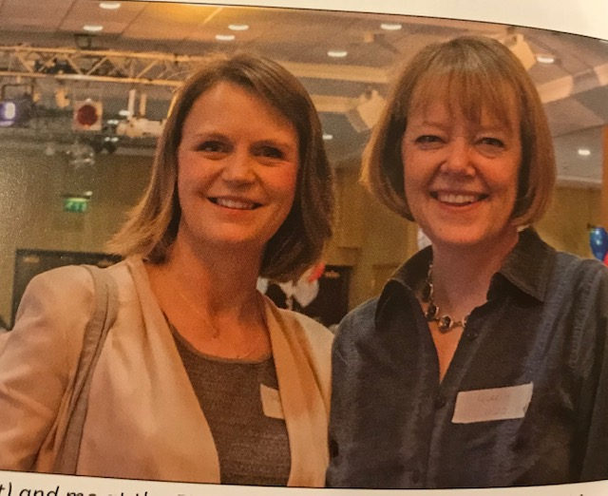

Gill and me at the FHLTA 30th Anniversary dinner.

Before writing this, I looked over the words I used for that speech and I found them to be something of a prophesy. In trying to capture the essence of the Freeman Transplant community, I quoted the co – founder of the London Marathon. John Brasher spoke of the running fraternity as a “joyous family: working together, laughing together, achieving the impossible”.

Little did I know what was ahead, nearly seven years later. This coming year, whatever it brings, I hope that, on behalf of the FHLTA, I can indeed achieve my very own “impossible”!
On that note, thanks to the lovely Louise McLellan, I am now officially registered to run the Virgin Money 2021 London Marathon for the Freeman Heart and Lung Transplant Association. The hotel is booked and the nerves are well and truly jittering.
If all goes to plan, this year’s London Marathon is hoped to become the world’s largest ever.
Fifty thousand runners are expected to gather in London on October the 3rd and 50,000 runners will also run virtually across the world! The FHLTA has secured three of these virtual places, allowing a few (lucky?) individuals to run the same distance over that weekend.
Email contact with Simon, the running coach, has both scared and inspired me. My mid - week runs this month need to be around 5 miles and longer runs need to build to 8 miles. It’s a gear shift, but snow depending, I’ll be on the case!

