London Marathon Journey – April

Traditionally, the London Marathon takes place in April. I’ve attended many times with my lovely (crazy) husband. I’ve smelled the Deep Heat, heard the foil blankets crinkling on the underground and seen the nervous air of anticipation. Mark’s first London marathon was many years ago now, before my transplant, in days when my hands and feet were always cold and a flight of stairs loomed like a mountain. My challenge on that day was to try and see him at Mile 20 (the point where many runners hit “the wall”) and offer a bit of moral support. Until this year, I would never have imagined being on the other side of the numerous metal barriers lining the streets.

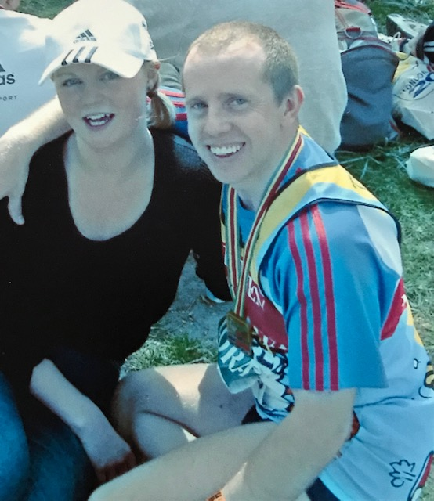

Mark proudly wearing his first London Marathon medal

This year, as you know, the London Marathon will be held in October and the good news is that the Freeman Heart and Lung Transplant Association has a team of four runners. We will each be clocking up miles and raising funds. More importantly, we will be raising awareness. Awareness that transplantation does so much more than save lives : it transforms them.
Louise, Tracey, Paul and I are all transplant recipients. It will be lovely to share this unique experience and to support each other through the blood, sweat, tears and blisters! We will be spending the 3rd of October running, walking, shuffling and cursing our way through our journeys of 26.2 miles.

This year, the event promises to be the largest ever, with runners competing in London and around the world. Louise, Paul and Tracey will be running virtually at a location of their choice. My experience will be slightly different. The same challenge : a different location. If I’m honest, at present, the idea of being in London, travelling on public transport and spending time amongst crowds of other people frightens me more than the run itself. That may alter as my distances increase !

This month has brought lots of changes for me personally. Throughout Lockdowns and the shielding period, I have worked from home, tried to keep fit and done some volunteering to feel connected and provide support to others. Last week, I finally began my return to work. The risk assessments are onerous and the PPE which I need to use feels daunting, but slowly it is becoming feasible for me to be there. As my time at work increases, it has become necessary to reduce my time volunteering and after ten months of answering calls on the British Red Cross national support line, I’ve completed my final shift. It’s been an amazing experience and I have learned so much from the volunteers and callers. I’m planning to concentrate on my fitness and running over the summer and then look to start a new volunteer role in the autumn.
My training is progressing (slowly). Some days it’s hard just to complete a 5km run and my legs feel so heavy. Other days, more is possible and my confidence increases with my milage. My plan for January was to ask the staff at local running shop to analyse my gait, to check whether some more supportive running shoes would be preferable. I’ve always used “neutral” running shoes but as the miles increase, it may prevent injuries if I have shoes which stop my feet from developing a poor position. Since shops have only just reopened, I’ve not been able to do this yet but I hope to next week. In May, my plan is to run 14 miles. This will be the longest distance I’ve ever tried to run and I know it will provide a taste of what lies ahead. Wish me luck!

