Mission accomplished:
Many months ago , during the time when I needed to “shield”, due to Covid 19, I had to contact the Transplant Clinic but couldn’t find an up to date email address. I headed to the website of the fantastic Freeman Heart and Lung Transplant Association (FHLTA) to see if I could find it. In the process, I came across a request for people to run the London Marathon. I typed a tentative email back to a lady called Louise!
Today, I’m back where it all began, at my kitchen table: typing. I can hardly believe that the journey is over and so much has happened along the way. Louise and I have been in regular contact since and I’m so looking forward to meeting her sometime soon. Both she and Paul completed the virtual event. I definitely thought of them as my partners in crime as I made my way around London.
I’ve always felt strongly that the marathon place belonged to the charity and not to me. Writing about the process has been my way to share it.
So what has the process taught me?

1. Runners can’t wear their skinny jeans anymore
2. Energy gels aren’t a gimmick, they give you super powers.
3. Writing your name on your running vest gives you extra support from the crowd (thanks Mark!)
4. Only when injury stands in your way do you realise how much you want to do this crazy challenge.
5. Friends stop asking you what you are doing at the weekend when they know your answer will inevitably be “running”.
6. Transplant recipients don’t need to Google “ways to build mental resilience” (we’ve got that one covered!)
7. Celebrating in Leicester Square with a drink afterwards really is a marathon rite of passage.

The day itself brought cool temperatures, sunny skies and a gentle breeze. The BBC weather presenter even uttered the words “perfect running conditions” .
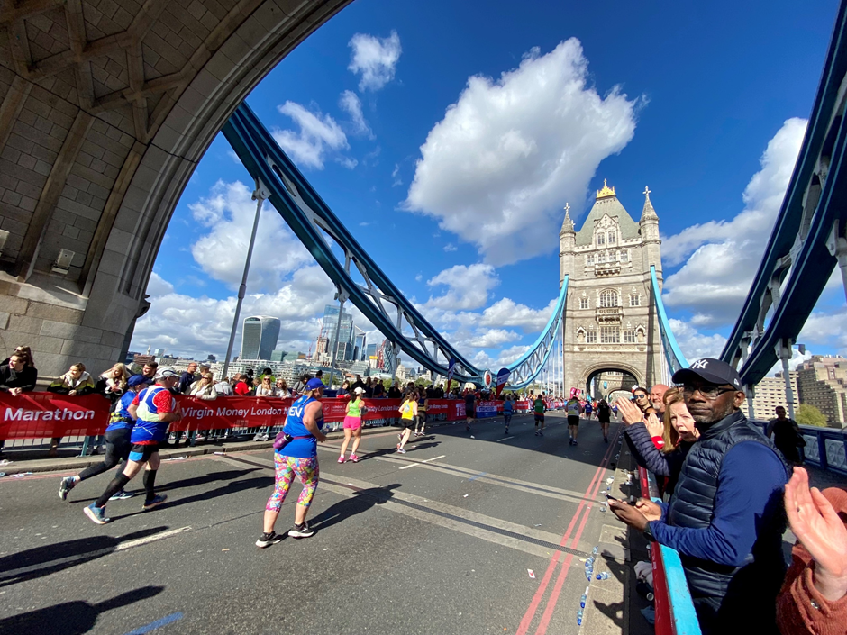

He was obviously talking about the elite and talented amateur runners, rather than those who happened to take more than 4 hours to reach Canary Wharf, because as we mere mortals reached the point where it all gets a bit tough (19 – 20 miles in) … the heavens opened and the wind whistled. If it had not been for the huge buildings and smooth rainy pavements I could have sworn I was back on my freezing 20 mile training run in Guisborough!

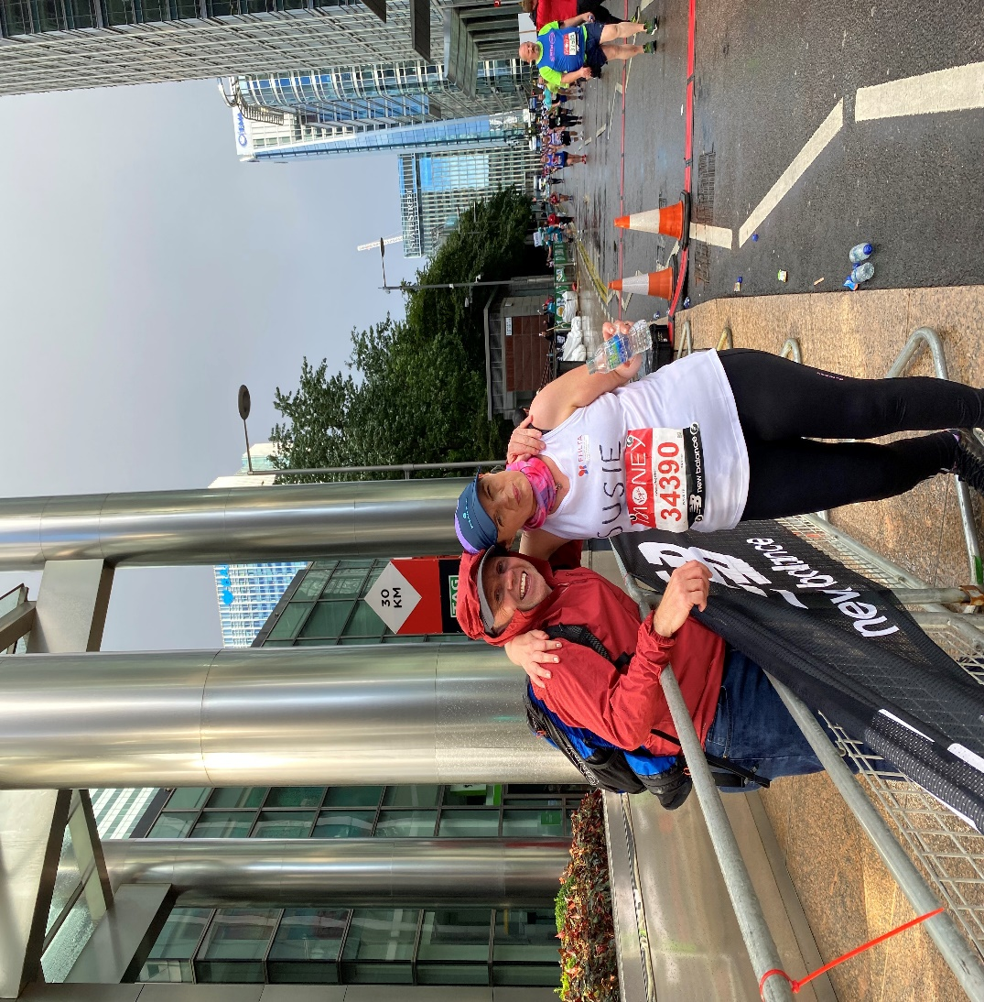

Luckily, the downpour was short-lived and the wind settled down. I distracted myself remembering the reasons why I wanted to complete this run : to keep myself fit and healthy in the face of a global pandemic which has been so frightening for transplant recipients; but also to inspire others and to demonstrate the power of transplantation to transform our lives.
The marathon represented a mile for every year of my life pre – transplant. As a child, I felt genuine terror at coming to London to visit the Brompton Hospital. London and I had unfinished business!
The last 6 miles were hard though. I’d felt a little light headed at the 18 mile point. I wanted this to be a really positive experience and to look after my body so I relaxed and jogged / walked the last section. I stopped to chat to other competitors, went to thank the marshals, the road sweepers, the charity groups and smiled every time there was a camera.
The finishing line appeared eventually and as I turned the corner past Buckingham palace, I felt a wave of teary emotion …. I’d done it!
Thank you to the FHLTA for allowing me to have such an amazing adventure ……
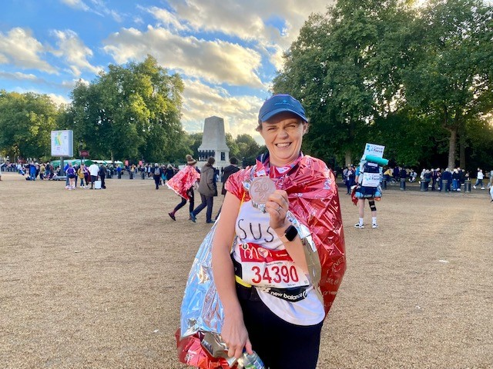

Marathon medals in our household always belong to Mark …. This one’s on me!

