BTG Coventry 2023

Following some last minute withdrawals 24 competitors and their suppporters gathered in Coventry between 27th and 30th July 2023 for the British Transplant Games.

Thursday
Events kicked off today with Archery and Snooker. At the archery we had 8 competitors including two of our new team members. In the experienced category Susan gained and amazing silver medal with Simon, Darren, Ivor, Miao, Davie, Craig and Debbie competing in the afternoon beginners session. Archery is always a lovely atmosphere and the sun was shining and I’d say everyone had an enjoyable day with an added bonus of Craig gaining a silver medal and Debbie a Gold!

Meanwhile at the snooker Liam was accompanied by new team member Kai and both reported an enjoyable time with Liam gaining a bronze medal.

After a quick turnaround the team congregated to a party atmsosphere in Coventry Centre at the Cathedral Ruins ahead of the opening ceremony. New member Kai Soanes had the privilege of leading the Freeman Team for the parade of teams round to Broadgate. The official opening took place including some live music from a talented transplant recipient and the most beautiful, touching poem written and delivered by 18 year old Doroti sister of a competitor Kristof as a tribute to her brother’s donor Justin: It was so beautiful and moving.

Here is her poem:

DEAR JUSTIN
Dear Justin, I thought about you today.
I think about you every day.
Yet it feels strange to know that we’ve never met and never will.
At least not in this world. Not whilst I’m still around on Earth.
Every time I think of you, everything stands still.

Dear Justin, I’m writing to tell you that my brother was only a few months old when he became ill.
He couldn’t eat, drink or even sleep.
“This medicine will make him better,”
“sorry it didn’t work, we’re trying our best,”
“biopsy next weekend,” “maybe it’d be better to lay him to rest.”
“I gave him the food, but he’s thrown it up again,”
and repeat, and repeat, and repeat.
My parents moved us overseas as we couldn’t accept defeat –
there had to be a way for him to live.
If only the odds had seen his smiling eyes,
the bright little mind and loving heart in the way that we all did.

Dear Justin, we arrived at our new home at the end of March:
we lived on the tenth floor of a flat overlooking the hospital;
the place where they told us he would need a new organ to live.
That a new organ is something only somebody else can give.

Dear Justin, he waited for the call with the phone grasped between his small fingers.
The glass table which we sat around reflected his jaundiced eyes like a mirror.
We waited. The phone slept by his bedside.
We waited. The phone sat by us in the daytime.
We waited some more. And more.
We waited. And the phone rang.
My parents grabbed the bags that were already packed and said goodbye but came back the next day for it wasn’t a match.
We waited. The phone slept by mum’s bedside.
We waited. The phone sat by her desk in the daytime.
We waited some more. And more.
We waited. And the phone rang.
My parents rushed from work and I was rushed from school to say goodbye, but they came back again for it wasn’t a match.
We waited. The phone slept.
We waited. The phone sat.
We thought of the sadness another would have to go through for him to receive his gift.
We dreamt about the new life his gift could bring.
And we waited some more. A week. Two weeks.
And the phone rang for the third time approaching February’s third week.
My parents grabbed the bags that were already packed, said goodbye but didn’t come back the next day for it was a match.
It was the night you had gone to heaven and given him a second chance.

Dear Justin, his eyes turned from jaundiced to white in a matter of days
and we celebrated his third birthday.
Candles weren’t allowed on the ward
and he couldn’t yet eat cake,
so we bought him a teddy and decorated his bedside with banners for the special day.

Dear Justin, he started to stare out of the window each night,
asking which star you are. If you are even a star at all?
Maybe a cloud in the shape of a smile or a heart,
or even the whole sky when the sun is out.
He asked if you’re watching him,
he asked if you are proud.
He asked: “why is it that he had to die because of me?”
And I know that if you could, you would have answered this, so I answered him: ‘he didn’t die because of you. He died and chose to give his gift to you.’

Dear Justin, my mum wrote a letter to your family.
She began writing even though she didn’t know how to start it.
She said ‘thank you’ didn’t seem enough,
so she filled the letter with photos and
all the things he can now do and dream of.
Your mum sent a letter back a few months after,
along with a portrait a friend of hers had drawn of you and him sat side by side.

Dear Justin, we told him all that your mum had said about you.
We told him your name, and gave him the portrait of you together in an orange frame.
He wanted to hug you. He wanted to meet you.
But we told him that we can’t in this world.
Not whilst we’re still around on Earth.
So he built a teddy, gave it a heart, named it Justin, and hugged it every day and every night.
He still dreamed about meeting you,
but we knew that meeting your family would be the closest thing to that dream coming true.

Dear Justin, we met your family on a day in early December.
Your mum told us stories about you.
She told him your favourite colour was blue,
and he smiled because that was his favourite colour too.

Dear Justin,
Today marks twelve years since you went to heaven.
Today we celebrate twelve years since his gift – as he blows out the candles of the cake my mum stayed up all night to make,
as we light the candle to remember you today –
I think back to the day your family took us to your favourite place…

From the shape of the leaves to the way the wind blows,
To the hope with which these trees grow,
The freedom with which the butterflies sing temporary goodbye,
And the endless life of your favourite-coloured sky.
From the way our feet fall into your footprints,
To your favourite bench on which we sit –
I see a piece of you living in everything…

[Twenty-one second silence in honour of the twenty-one years Justin lived]

Dear Justin,
Twenty-one feels long when you
stand through every second of it in silence.
I wonder how it felt to live through it in your silence.

I wonder if you know how loved you are.
I wonder if you know much you are missed.
I wonder if you know how much he cares for your gift.

Dear Justin, people may say that it’s impossible
to have memories of someone you’ve never met,
but I want memories of you.
I want to remember you.
We are remembering you for what we know is true:

that even when life no longer brought you light,
you raised your voice to allow your light
to bring life to someone else.
That you chose for your last gift on Earth to be the gift of life…

Following the ceremony the team went back to the hotel for a team meal where we had the pleasure of being joined by the lovely Maureen Allen (mum to our much beloved and never forgotten team member Mark Allen ️).

Friday
Today was the turn of the cyclists, ten pin bowlers and the table tennis crew.
Simon and Stuart represented the cyclists and reported and enjoyable event and a great return to cycling for Simon who lost his passion over the past few years but now fully ignited again with a Stirling 5th place as well.

Table Tennis saw the boys Gordon and Alex take the new girls Miao and Vicky under their wing and they can’t have done a bad job as Miao left with a silver medal and Vicky a bronze so well done guys!

At ten pin we had 10 competitors (Rebecca, Susan, Kai, Linzi, Darren, Liam, Dan, Lisa, Davie and Debbie. As a spectator the atmosphere and support during each game is always inspiring and all had a great day.

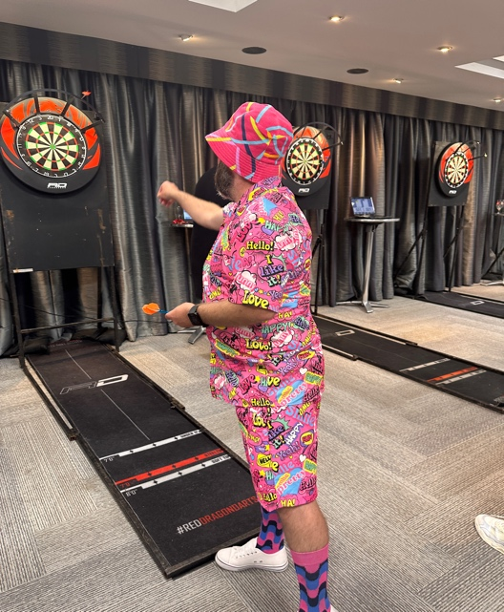
Friday evening was the turn of our Darts players which is also a social night with a loud shirt theme. Think team member Simon Ripley gets the prize for embracing this!
Our players Rebecca Long, Kai Soanes, Simon Ripley, Darren Veevers, Ivor Morris, Shane Smith and Lisa Hertwig had plenty of supporters cheering them all and a great night was had by all.

Saturday
Busy day again with Alex, Vicky, John and Craig in action at the badminton resulting in a bronze medal for Craig and silver for John. Myself and Miao meanwhile took part in the 3k walk at the track with myself gaining gold and Miao gaining bronze. At the same time Susan, Kai, Liam and Ivor were taking part in bowls reporting an enjoyable day. New team member Shane was at Football and Kirston in the end was our only swimmer this year but did amazing with her two freestyle events and first prize has to go to Kirston’s supporters who rocked it with their personilsed support banner!!

Back for a quick change to then congregate ahead of the event of the weekend the Donor run/walk.

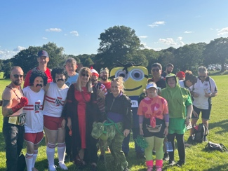
As has been the case since 2019 many of our team go fancy dress and this year did not disappoint with special guest appearance from a Minion (aka Simon Ripley). We were also joined by other FHLTA members including Shaun Winter, Steven Firn, Adam Ellwood, Vicky Pettersen and a with a great atmosphere and sun shining. Think we all did our donors proud.

Sunday
Athletics started with Craig throwing Discus with a great start including a gold medal!. Myself, Debbie and Davie then threw Javelin at various times during day. No injuries and a bronze medal from myself whilst Rebecca, Linzi, Liam , Lisa and Katy took part in ball throw and myself and Craig completed the throwing with Shotputt with me gaining silver and Craig bonze. Turning to the track and Miao did the 100m. By this stage the weather had turned from glorious sunshine to pouring rain. Miao had a great start but then a little tumble was elegantly displayed but despite really hurting herself in the chest immediately got up and continued to the end to take the bronze which was amazing.

After drying off and recovering at the hotel the team headed to Warwick University Campus for the Celebration Event. A really lovely and enjoyable night during which we awarded our team awards which the team vote for all week.

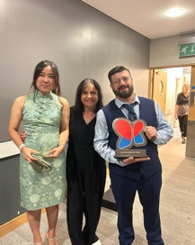
The Joan Whitney Memorial Trophy for the newcomer went to the lovely Miao Cowen whilst the beautiful new Derek Airey Memorial Trophy was awarded to Liam Waterworth. Both these were very well deserved but I think everyone will agree there was no one on the team that didn’t make an impact. Probably why the voting was so close for many candidates.

The night continued with some dancing, drinking and planning when we will next all be together.

I can say honestly from the heart this has been an amazing team to look after, each have given so much and in my opinion embraced what the games are all about.

A special thanks goes to Assistant Sports Manager Lisa Hertwig for all her help in the planning not to mention the updating of our social media accounts throughout the weekend and to Debbie Burdon for the sorting the financial side of it during the weekend and in the coming days.
