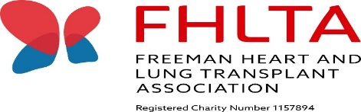
FREEMAN HEART & LUNG TRANSPLANT ASSOCIATION

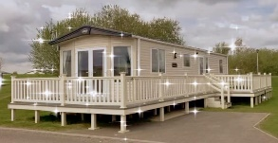
Tattershall Lakes Price List & Booking Form
Rate | Week long stay  Sat – Sat | Mini breaks  Mon – Fri/ Fri – Mon
Peak | £850.00 | £450.00
Off peak | £650.00 | £350.00
Pets | £20.00 per stay | £20.00 per stay
*Peak times are all bank holidays, public holidays and school holidays**
**A minimum of 3 nights stay is required to book**
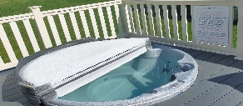
A £75 deposit is required to secure ALL bookings.
Once your dates have been confirmed by either
Adele Lambert or Debbie Burdon an invoice will be sent via
email or post for your £75.00 deposit.

A further invoice for your holiday balance will be sent closer to your stay and needs to be paid in full 4 weeks before your arrival date.
**Your deposit will only be returned after your stay, providing conditions are met**

To submit a completed booking form or to enquire about availability please contact either:
Adele Lambert, FHLTA Chair: 01325 310905
Debbie Burdon, FHLTA Treasurer: 07532 229 850
Alternatively via email: Enquiries@fhlta.org.uk or via Facebook messenger.

BOOKING FORM (Please complete all sections)
Full Name:
Address:
Post Code:
Phone number:
Email address:

Date of Stay: | Arrival date: / /2023 |  | Departure date: / /2023
Number of nights:
Number of people (max 6) | Adults: | Children: |  | Number of pets (max 2)

Payment in full must be made by cheque payable to the FHLTA and sent to the FHLTA correspondence address or by bank transfer to the Freeman Heart and Lung Transplant Association. These details will be on your invoice.
Please confirm you have read, understood and agree with the terms and conditions attached: Yes☐ No ☐

Terms & Conditions 2024/2025
The contract is for a short-term holiday rental of our FHLTA luxury static caravan at Tattershall Lakes Country Park in Lincoln. The contract entered into is between the FHLTA and the holidaymaker (the hirer who enquires or completes a returned booking form).
Bookings are accepted on the understanding that the property is taken for holiday purposes only and that the maximum occupancy of the caravan is not exceeded (6 people, 2 pets).
The hirer and any friends or family of the hirer visiting the property must adhere to the rules and procedures set out in the guidance folder provided in the FHLTA static caravan.
Period of Hire
Rentals for the caravan will commence at 4pm on the day of arrival and terminate at 10am on the day of departure.
Payment
Once the booking is confirmed by the FHLTA Chair or Treasurer you will receive an invoice by post or email requesting payment of your £75.00 deposit to confirm your booking. Information on how to pay your invoice will be provided within the document. A further invoice for your holiday balance will be sent separately closer to your stay and must be paid in full 4 weeks before arrival. Failure to do so may put your booking and deposit at risk. Once full payment is received you will receive documents on the self check in process up to a week prior to arrival.
Security/Breakages Deposit
The deposit of £75.00 is a security/ breakages deposit which is required to be held until the cleaner has been in to check the caravan. The cleaner checks all aspects of the caravan’s contents and equipment, cleanliness and tidiness ahead of arrival and at every departure. Please contact us or leave a note for the cleaner if there is anything accidentally damaged so it can be replaced, to ensure all guests have everything in working order. However, please note that if the caravan does not pass the cleaners inspection or is left in an unclean or untidy condition, caravan and/or hot tub rules are not followed, things are broken or damaged this may result in your deposit may not being returned!
Cancellations

The hirer is advised to arrange holiday insurance to give protection in the event that the hirer is unable, for any reason, to take up the holiday accommodation at the agreed time. The hirer should inform the FHLTA of any cancellation immediately. In the event of cancellation your £75.00 will not be returned. In expectational circumstances and only at the discretion of the FHLTA your deposit will be returned.
Bed linen
Bed linen is provided in the caravan and beds will be made ready for you and the number of people staying.
Towels
Please note we DO NOT provide towels; you will be required to bring your own with you.
Pets
Pets are allowed for a £20 fee for extra cleaning charge. The hirer and guests are asked to refrain from pets being allowed on furniture and beds. Please bring your own. There are bowls for your pet to use under the sink.
Rules and Procedures
Hirers are required to observe the rules and familiarise themselves with the procedures contained in the guidance/welcome folder provided in the caravan. If these rules or the park rules are not adhered to you may be asked to leave and your deposit may not be returned.
Smoking, Candles and BBQs
Smoking is not permitted in the caravan at any time, this also applies to visitors to the caravan.
Candles or naked flames are not to be used within the caravan. No BBQs are allowed near or around the caravan.

