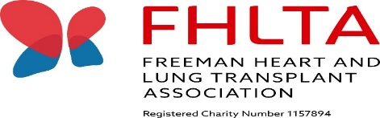
FREEMAN HEART & LUNG TRANSPLANT ASSOCIATION

Whitley Bay Caravan Price List & Booking Form
Rate | Week long stay  7 nights | Mini breaks  Mon – Fri/ Fri – Mon | Extra nights
Peak | £400.00 | £300.00 | £70.00 per night
Off peak | £350.00 | £250.00 | £60.00 per night
Pets | £20.00 per stay | £20.00 per stay | £20 per stay
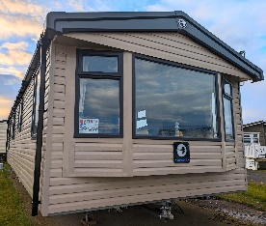
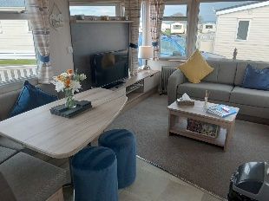
*Peak times are all bank holidays, public holidays and school holidays**
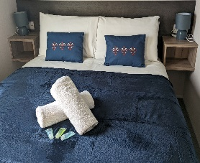
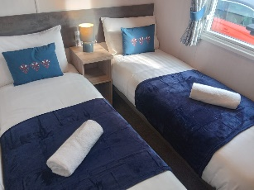
**A minimum of 3 nights stay is required if booking extra nights only**

An additional £50 deposit is required to secure ALL bookings.
Once your dates have been confirmed an invoice will be sent
via email or post (if no email access) for your £50.00 deposit.
A further invoice for your holiday balance will be sent closer to your stay and needs to be paid in full 4 weeks before your arrival date.

**Your deposit will only be returned after your stay, providing conditions are met**

To submit a completed booking form or to enquire about availability please contact either:
Adele Lambert, FHLTA Chair: 01325 310905
Debbie Burdon, FHLTA Treasurer: 07532 229 850
Alternatively email completed form: Enquiries@fhlta.org.uk or via Facebook messenger.

BOOKING FORM (Please complete all sections)
Full Name:
Address:
Post Code:
Phone number:
Email address:

Date of Stay: | Arrival date: / /2024 |  | Departure date: / /2024
Number of nights:
Number of people (max 8) | Adults: | Children: |  | Number of pets (max 2):
Number of beds needed | Double: | Singles
 | Singles: | Are separate rooms needed for singles:

Payment in full must be made by cheque payable to the FHLTA and sent to the FHLTA correspondence address or by bank transfer to the Freeman Heart and Lung Transplant Association. These details will be on your invoice.

I have read, understood and agree to adhere to the terms and conditions attached: Yes☐ No ☐

FHLTA Whitley Bay Caravan Terms & Conditions 2024/2025
The contract is for a short-term holiday rental of our FHLTA static caravan at the Parkdean Resort, Whitley Bay Holiday Park in Whitley Bay. The contract entered into is between the FHLTA and the holidaymaker (the hirer who enquires or completes a returned booking form).
Bookings are accepted on the understanding that the property is taken for holiday purposes only and that the maximum occupancy of the caravan is not exceeded (8 people, 2 pets).
The hirer and any friends or family of the hirer visiting the property must adhere to the rules and procedures set out in this document and the welcome/guidance folder provided in the FHLTA static caravan.
Period of Hire
Rentals for the caravan will commence at 4pm on the day of arrival and terminate at 10am on the day of departure. Check in is none contact and you will be given details ahead of your arrival date.
Payment
Once the booking is confirmed by the FHLTA Chair or Treasurer you will receive an invoice by post or email requesting payment of your £50.00 deposit to confirm your booking. Information on how to pay your invoice will be provided within the document. A further invoice for your holiday balance will be sent separately closer to your stay and must be paid in full 4 weeks before arrival on by the invoice date. Failure to do so may put your booking and deposit at risk. Once full payment is received you will receive documents on the self check in process up to a week prior to arrival.
Security/Breakages Deposit
The deposit of £50.00 is a security/ breakages deposit which is required to be held until the cleaner has been in to check the caravan. The cleaner checks all aspects of the caravan’s contents and equipment, cleanliness and tidiness ahead of arrival and at every departure. Please contact us or leave a note for the cleaner if there is anything accidentally damaged so it can be replaced, to ensure all guests have everything in working order. However, please note that if the caravan does not pass the cleaners inspection or is left in an unclean or untidy condition, caravan rules are not followed, things are broken or damaged this may result in your deposit may not being returned!
FHLTA passes to the entertainment complex are provided free for your use for the duration on your stay and will be in the caravan for your arrival. These allow FHLTA guests to access activity and entertainment areas, bars and restaurants and provide some discounts as these are owner passes. There is a charge for some activities. All activities can be booked in advance by contacting the caravan park directly. Please leave these behind at the end of your stay for other guests. There will be a charge if these are lost.

Cancellations

The hirer is advised to arrange holiday insurance to give protection in the event that the hirer is unable, for any reason, to take up the holiday accommodation at the agreed time. The hirer should inform the FHLTA of any cancellation immediately. In the event of cancellation your £50.00 will not be returned. In expectational circumstances and only at the discretion of the FHLTA your deposit may still be returned.
Bed linen
Bed linen is provided in the caravan and beds will be made ready for you and the number of people staying. We will need to know the amount of people staying and the amount of beds required prior to your stay. Only beds needed will be made up by the cleaner.
Towels
One small bath towel and one hand towel per person will be provided for your use.
Two tea towels and one bathmat will be provided for your stay.
Pets
Pets are allowed for a £20 fee which covers additional cleaning. The hirer and guests are asked to refrain from pets on the furniture and beds. Please bring your dog bed.
Rules and Procedures
Hirers are required to observe the rules and familiarise themselves with our procedures contained in the guidance/welcome folder provided in the caravan. Park rules also must be followed and if rules and/or procedures of the FHLTA or the park are not adhered to you may be asked to leave by the caravan park or by the FHLTA and your deposit or holiday cost will not be returned.
Smoking, Candles and BBQs
Smoking or vaping is not permitted in the caravan at any time, this also applies to visitors to the caravan.
Candles or naked flames are not to be used within the caravan. No BBQs are allowed near or around the caravan.
Please check the box on the booking form of you had read, understand and will adhere to these terms and conditions.

Thank you
FHLTA Trustees

